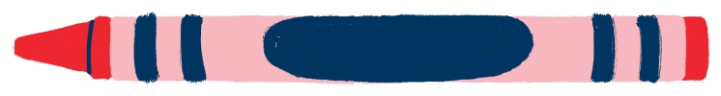

June-Aug 2025

Early Lit (0-5)(Mon) Children (6-12)(wed) Teen/ Young Adult (12-18)(fri)

June 9th ~ Self portrait on tile June 11th ~Dave Porter(wheel) June 13th ~Self portrait

June 16th ~Marble/Paint in Box June 18th ~Spatter Mural June 20th ~Mural Game

June 23rd ~Starry Night Mural June 25th ~ Starry Night Mural June 27th _ Sunflower Mural

June 30th ~TP roll (fringe) fireworks July 2nd ~Statue of Liberty Mural July 3rd~Statue of Liberty Mural

July 7th ~Playdoh & Silly straw sculptures July 9th ~Melted Cup Sun catchers July 11th ~ Sun Catchers

July 14th ~ Paint Under Table July 16th ~ Paint Under Table July 18th ~ Vitruvian Man

July 21st ~ Tie dye oven mitts July 23rd ~ Tie-dye/Batik July 25th ~ Tie-dye/Batik

July 28th ~ Pompom Pictures July 30th ~ Lego Pictures Aug 1st ~ Eraser Pointillism

Aug 4th ~ Repetitive Warhol Aug 6th ~ Handy Warhol Aug 8th self portrait

**All Reading logs will be due August 10th for the Reading Challenge. August 12th will be Reward Day!!**